Django History

Django is web application framework, used for developing dynamic web applications.
Django framework is completely written in python language using WSGI standards.
Django is developed using one programming concept called DRY (Dont Repeat Yourself)
Django is called RAD (Rapid Application Development Tool)
Django is called full stack web framework (every thing is included as part of django framework)
Django is developed by Adrian Holovaty, Siman Willison
Django is maintained by an organization DSF (Django Software Foundation)
Django was created in the year 2003 as an internal project at Journal World News web developed.
This first version of django is released for public in 2005
official website of django is www.djangoproject.com
Django name is taken from popular guitarist Django Reinhardt
=======================================================
Django Versions
=======================================================Current version of django is django 6.0 is Python compatibility: 3.12, 3.13, 3.14
django 5.0 which is compatible on python 3.10 to 3.14
django 4.0 which is compatible on python 3.8 to 3.12

install django framework

pip install django

django package is installed in python software folder

c:\users\satish gupta\appdata\local\programs\python\python312\lib\site-packages

How to find current version (OR) version installed inside system

python –m djnago –version

-m 🡪 module
--version 🡪 to return module version

IDE’s used for developing web applications

- VSCODE
- PyCharm
- Atom

Django Project

For developing web application using django first step is creating django project.

What is django project?
Django project is collection of web applications and configuration files.

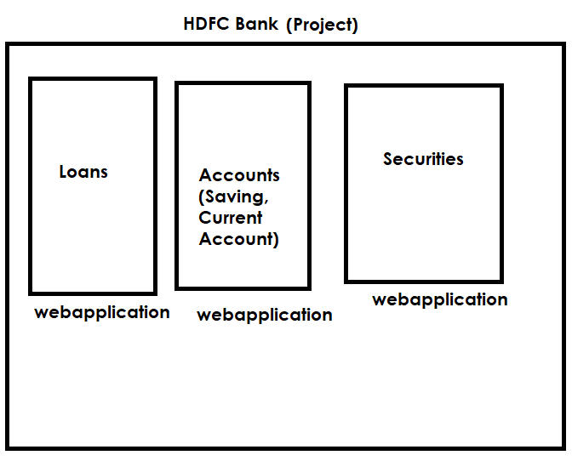

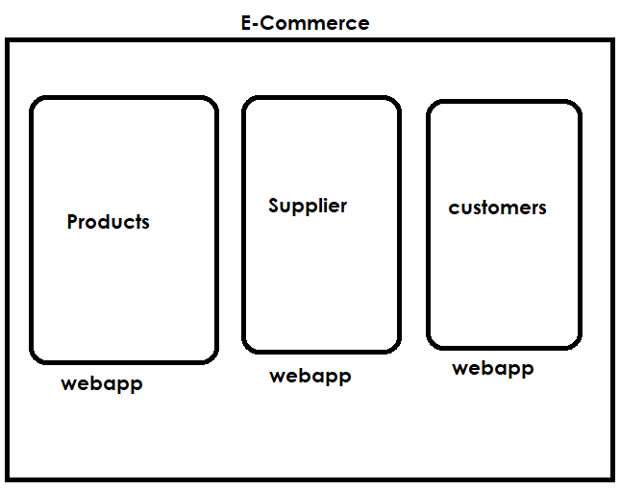

How to create django project?

- Open VSCODE
- Open Terminal 🡪 view 🡪 terminal

PS C:\Users\Satish Gupta> cd D:\Backup\Django9amMar
PS D:\Backup\Django9amMar>

django-admin

django-admin is a command or commandline utility for managing django projects and applications.

django-admin startproject <project-name>

PS C:\Users\Satish Gupta> cd D:\Backup\Django9amMar
PS D:\Backup\Django9amMar> django-admin startproject project1
PS D:\Backup\Django9amMar>

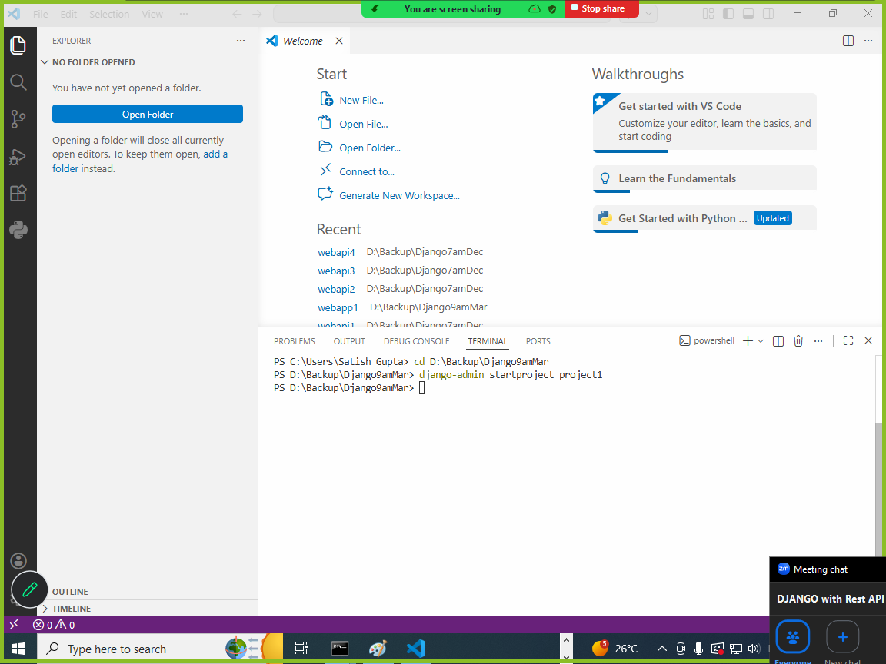

Open project
File 🡪 Open Folder 🡪 project1

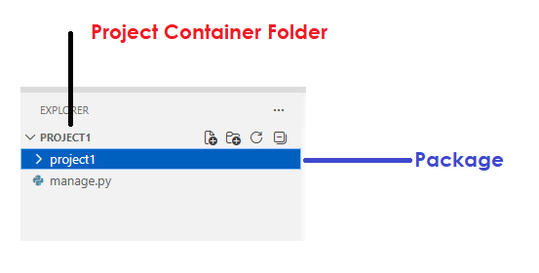
Project container folder contains,
- Package (with project name)
- Manage.py

What is manage.py?
manage.py is a python program or commandline utility.
This command or program is used for performing following operations

- Create application
- Database migrations
- Manage Static Resources
- Running server
- Creating superusers
- Django shell
- Debugging

